**PIR MOTION DETECTION SYSTEM:**

PROGRAM:

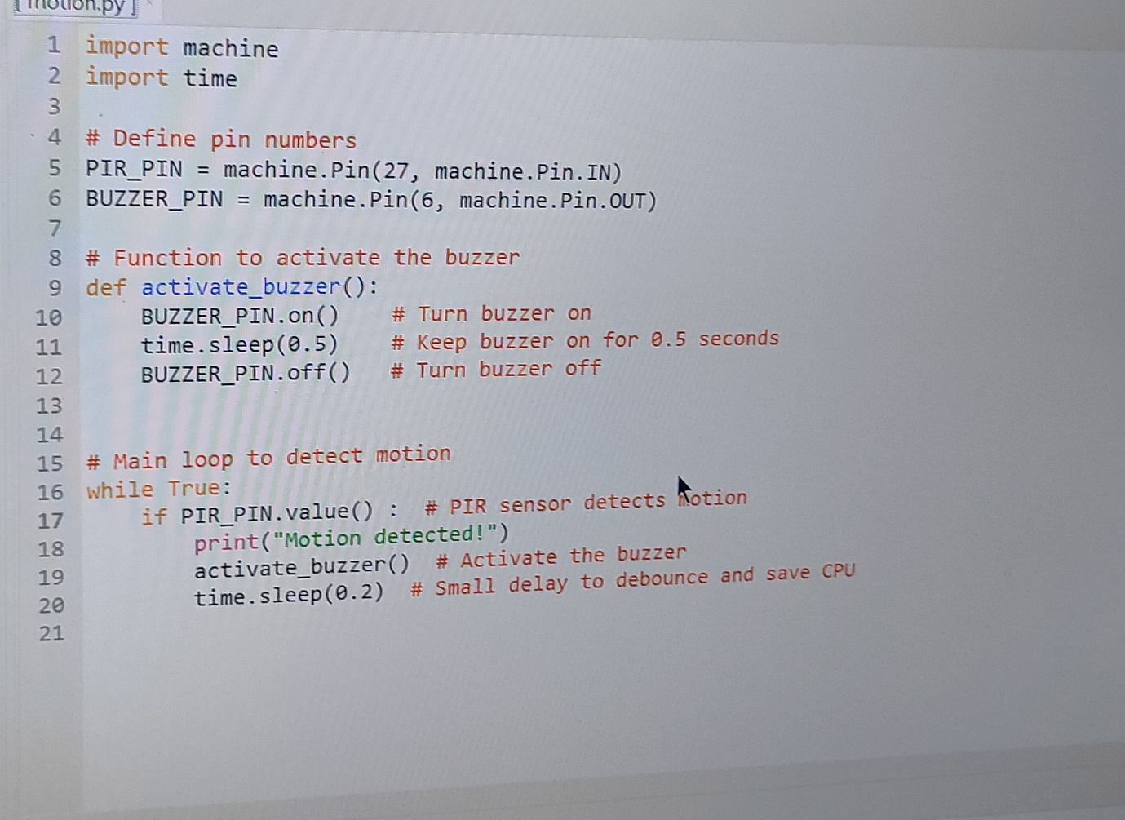

OUTPUT:

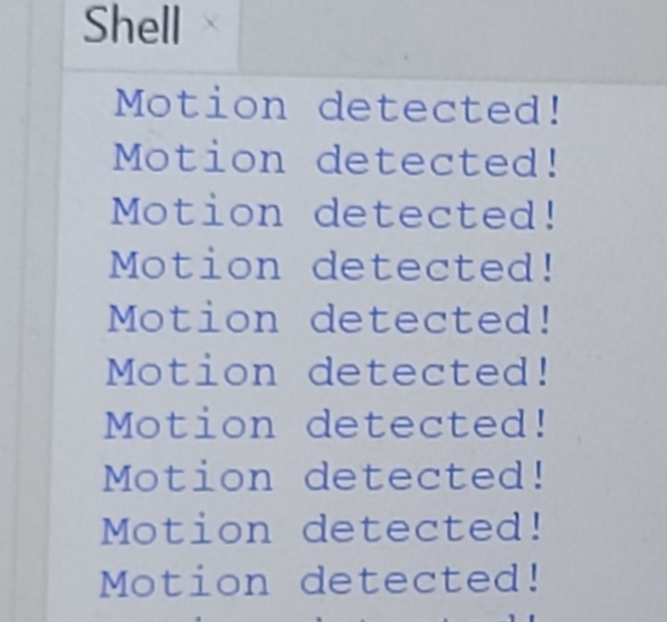

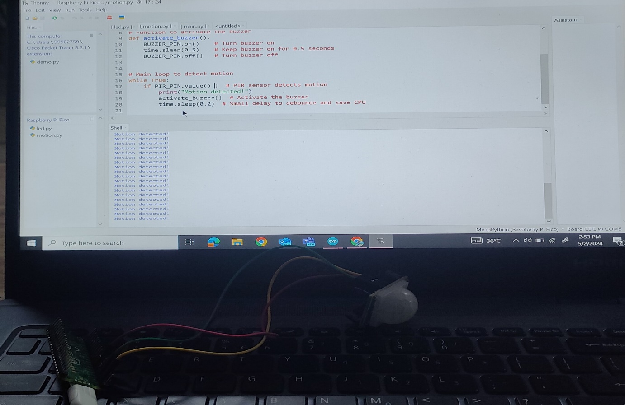

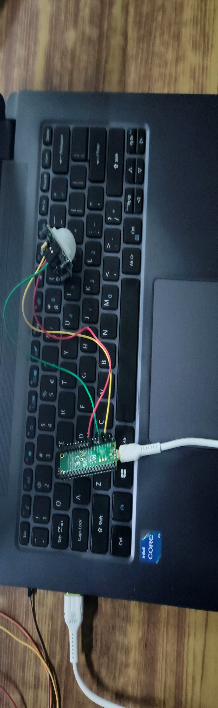

2181A04D2:P RASOOL BASHA

2181A04D3:P NANDAGOPAL

2181A04E2:P RAKESH

2181A04C6:M BHASKAR